**Marketplace Technical Foundation -**

**Fashion network**

# 1. System Architecture Document

## 1.1 Overview

The marketplace website for fashion network is designed to allow customers to browse and purchase trendy jeans and jackets. The system consists of several key components:

* **Frontend**: A React-based web application that provides the user interface for customers to interact with the marketplace.
* **Backend**: A mock API that simulates the processing of data, including fetching clothing items, handling user interactions, and performing CRUD operations.
* **CMS**: Sanity CMS to manage and store content such as clothing details, categories, and other relevant information.
* **Database**: The database is integrated with Sanity to store data related to clothing items, customer profiles, and order histories.

# 1. Frontend

* **Homepage**: A page that showcases banners, featured products, categories, and easy navigation.
* **Product Listing**: Displays a grid of clothing items with filters such as size, color, category, and price range.
* **Product Details**: A page showing detailed information for each clothing item (description, images, size options).
* **Cart**: A section to review and modify selected items before checkout.
* **Checkout**: A user-friendly interface for finalizing orders, entering payment information, and selecting delivery options.
* **Track Order** A dedicated page to track the delivery status of placed orders.

# 2. Sanity CMS

* **Product Management**: Store and manage product details like name, price, category, sizes, images, and descriptions.
* **Order Management**: Track customer orders, payment status, and shipping details.

# Third-Party APIs

1. **Payment Gateway**: o Integrate **Stripe** or **PayPal** for secure and reliable payment processing.
   * Features include:
     + Credit/debit card payment support.
     + Multi-currency support for international transactions. ▪ Refund and dispute management.
2. **Shipment Tracking**:
   * Use **AfterShip** or similar courier APIs to provide real-time tracking information for customer orders.
   * Features include:
     + Real-time status updates (e.g., Shipped, Out for Delivery, Delivered).
     + Notifications for order movement.
3. **Mock API**:
   * Create a **Mock API** for development and testing purposes to simulate data and API responses without relying on live APIs.
   * Features include:
     + Simulating **product data**, **order statuses**, and **tracking updates**.

▪

## API Structure

### Products API

* **Endpoint Name:** /api/products o **Method:** GET o **Purpose:** Fetch all products in the store.
  + **Request Parameters:** None o **Response:** List of products with details (e.g., name, price, category, etc.).
* **Endpoint Name:** /api/products/{id} o **Method:** GET o **Purpose:** Fetch a single product by ID. o **Request Parameters:** id (Product ID) o **Response:** Product details (e.g., name, price, description, images).
* **Endpoint Name:** /api/products o **Method:** POST o **Purpose:** Add a new product to the store.
  + **Request Parameters:** name, price, description, category, image o **Response:** Success message or product object with created data.
* **Endpoint Name:** /api/products/{id} o **Method:** PUT o **Purpose:** Update product details.
  + **Request Parameters:** id, name, price, description, category, image o **Response:** Updated product details.
* **Endpoint Name:** /api/products/{id} o **Method:** DELETE o **Purpose:** Delete a product by ID. o **Request Parameters:** id (Product ID)
  + **Response:** Success message or error message.

### Categories API

* **Endpoint Name:** /api/categories o **Method:** GET o **Purpose:** Fetch all product categories.

o **Request Parameters:** None o **Response:** List of categories (e.g., Korean style, Western, Old Money).

* **Endpoint Name:** /api/categories/{id} o **Method:** GET o **Purpose:** Fetch a single category by ID. o **Request Parameters:** id (Category ID) o **Response:** Category details (e.g., name, description).

### Orders API

* **Endpoint Name:** /api/orders o **Method:** GET o **Purpose:** Fetch all orders for the user. o **Request Parameters:** user_id (User ID) o **Response:** List of orders for the user, including status and product details.
* **Endpoint Name:** /api/orders/{id} o **Method:** GET o **Purpose:** Fetch details of a single order.
  + **Request Parameters:** id (Order ID) o **Response:** Order details (e.g., items, total price, shipping info).
* **Endpoint Name:** /api/orders o **Method:** POST o **Purpose:** Place a new order.
  + **Request Parameters:** user_id, items (Product IDs with quantities), shipping_address o **Response:** Order confirmation and details.
* **Endpoint Name:** /api/orders/{id}/ship o **Method:** POST o **Purpose:** Mark an order as shipped.
  + **Request Parameters:** id (Order ID), shipping_provider, tracking_number o **Response:** Shipment details with provider and tracking info.
* **Endpoint Name:** /api/orders/{id}/tracking o **Method:** GET o **Purpose:** Fetch tracking information for a shipped order.
  + **Request Parameters:** id (Order ID) o **Response:** Tracking details (e.g., shipping provider, status, delivery ETA).

### Users API

• **Endpoint Name:** /api/users/{id} o **Method:** GET o **Purpose:** Fetch user profile.

o **Request Parameters:** id (User ID) o **Response:** User profile details (e.g., name, email, shipping info).

### Authentication API

* **Endpoint Name:** /api/auth/register o **Method:** POST o **Purpose:** User registration.
  + **Request Parameters:** name, email, password o **Response:** Success message or user object.
* **Endpoint Name:** /api/auth/login o **Method:** POST o **Purpose:** User login.
  + **Request Parameters:** email, password o **Response:** Success message and user authentication token.

### Cart API

* **Endpoint Name:** /api/cart o **Method:** GET o **Purpose:** Fetch cart details for the user.
  + **Request Parameters:** user_id o **Response:** Cart items with quantities and total price.
* **Endpoint Name:** /api/cart/{id} o **Method:** POST o **Purpose:** Add an item to the user's cart.
  + **Request Parameters:** user_id, product_id, quantity o **Response:** Updated cart details.
* **Endpoint Name:** /api/cart/{id} o **Method:** DELETE o **Purpose:** Remove an item from the user's cart.
  + **Request Parameters:** user_id, product_id o **Response:** Updated cart details.

### **System Workflow**

#### • Login/Signup

* **User Action:** User initiates login or signup.
* **API Call:** POST /api/auth/register (Frontend → Backend).
* **Data Management:** User details are saved in Sanity.

• **Home Page**

o **User Action:** User lands on the home page after login or signup.

#### • Product Page

* **User Action:** User views a list of available products. o **API Call:** GET /api/products (Frontend → Backend).
* **Data Management:** Backend fetches all product data from Sanity.

#### • Single Product Page

* **User Action:** User clicks on a product to view details.
* **API Call:** GET /api/products/{id} (Frontend → Backend).
* **Data Management:** Backend fetches the product details by ID from Sanity.

#### • Add to Cart

* **User Action:** User adds a product to their cart.
* **API Call:**
  + GET /api/cart to fetch current cart details (Frontend → Backend).
  + POST /api/cart/{id} to add the product to the cart (Frontend → Backend).
* **Data Management:** Backend updates the user's cart details in Sanity.

• **Cart Page**

o **User Action:** User navigates to the cart page by clicking the cart icon.

#### • Checkout

* **User Action:** User clicks the "Place Order" button and provides order details.
* **API Calls:**
  + POST /api/orders to create a new order (Frontend → Backend).
  + POST /api/cart/{id} to confirm items in the cart (Frontend → Backend).
* **Data Management:** Backend saves the order details and updates the cart in Sanity.

#### • Track Order

* **User Action:** User tracks their order status.
* **API Call:** GET /api/orders/{id}/tracking (Frontend → Backend).
* **Data Management:** Backend fetches tracking details from ShipEngine and provides them to the user.

### **Third-Party Services**

#### • Mock.io

* Provides a mock API for product data.
* Data fetched by the Backend and stored in Sanity for future use.

#### • ShipEngine

o Used to track order shipping status. o Provides tracking information to the Backend, which is displayed to the user.

**Design System Architecture:**

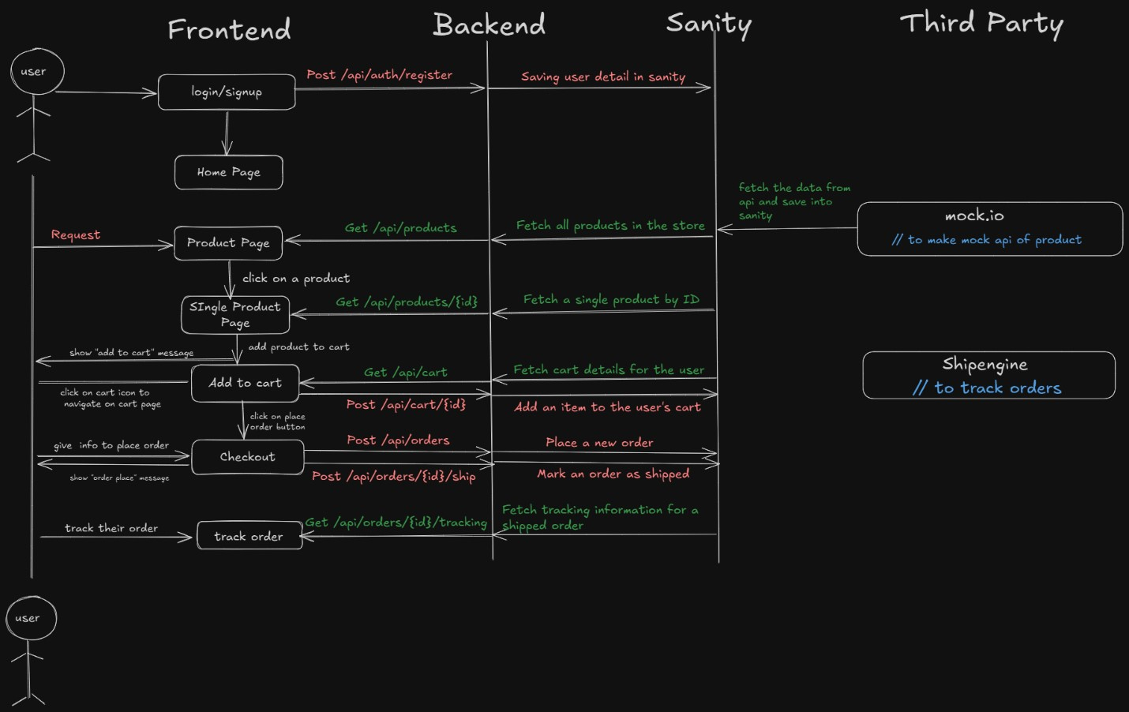

# Sanity Schema

## Product Schema

export default { name: 'product', title: 'Product', type: 'document', fields: [ {

name: 'name', title: 'Product Name', type: 'string',

validation: Rule => Rule.required().min(3).max(50) }, {

name: 'slug', title: 'Slug', type: 'slug', options: { source: 'name', maxLength: 96,

},

validation: Rule => Rule.required()

}, {

name: 'description',

title: 'Description', type: 'text',

validation: Rule => Rule.required().max(300)

}, { name: 'price', title: 'Price', type: 'number',

validation: Rule => Rule.required().positive()

}, {

name: 'category', title: 'Category', type: 'string', options: { list: [

{ title: 'Korean Style', value: 'korean-style' },

{ title: 'Western Clothes', value: 'western-clothes' },

{ title: 'Old Money Fashion', value: 'old-money-fashion' },

], },

validation: Rule => Rule.required()

}, {

name: 'images', title: 'Images', type: 'array', of: [{ type: 'image' }], options: { hotspot: true,

},

}, { name: 'stock', title: 'Stock', type: 'number',

validation: Rule => Rule.required().min(0),

}, { name: 'sizes', title: 'Sizes', type: 'array', of: [{ type: 'string' }], options: { list: [

{ title: 'Small', value: 'S' },

{ title: 'Medium', value: 'M' },

{ title: 'Large', value: 'L' },

{ title: 'Extra Large', value: 'XL' },

], },

validation: Rule => Rule.required().min(1)

}, {

name: 'createdAt', title: 'Created At', type: 'datetime', initialValue: () => new Date().toISOString(),

},

], };

# Purpose of Documentation

1. **Team Alignment**: Provides a shared understanding of the project architecture, workflows, and APIs to ensure all team members are aligned.
2. **Scalability**: Acts as a reference guide for adding new features or scaling the system without disrupting the existing architecture.
3. **Onboarding**: Simplifies the onboarding process for new developers by giving them clear insights into the system.
4. **Troubleshooting**: Helps identify and resolve issues by offering detailed workflows and data structures.
5. **Consistency**: Ensures uniformity in code standards and workflows across the team.
6. **Client Communication**: Serves as a professional document to explain the project’s architecture and workflows to stakeholders or clients.